**Exp 10: Content Creation (Reports, Articles, Case Studies, etc.)  Using Prompt Patterns**

**Aim:**

To demonstrate how various prompting techniques (query decomposition, decision-making, semantic filtering, etc.) can be employed to create content such as reports, articles, case studies, or creative works like comic books, using ChatGPT or similar models. The objective is to highlight how different prompt structures affect the content's quality, coherence, and structure.

**Procedure:**

1. **Introduction to Prompt Patterns:** Begin by understanding the following prompt patterns:
   * **Query Decomposition**: Breaking down complex queries into smaller, actionable parts.
   * **Decision Making**: Asking the model to choose between options or directions.
   * **Answer Engineering**: Refining outputs by giving detailed instructions on how to structure or format the answer.
   * **Fact Check List**: Ensuring the content is factually accurate, especially for reports or case studies.
   * **Tail Generation**: Extending the content logically to create depth in storytelling or analysis.
   * **Menu Actions**: Presenting multiple action choices and guiding the AI to select one.
   * **Semantic Filter**: Applying filters to control the tone, style, and accuracy of the content.
2. **Choosing the Content Type**: Decide on the type of content you want to create. This could be:
   * **Reports** (e.g., industry analysis, sustainability reports, etc.)
   * **Case Studies** (e.g., business solutions, technological innovations)
   * **Articles** (e.g., opinion pieces, educational articles)
   * **Creative Content** (e.g., comic book story, short stories, video scripts)
3. **Creating the Prompts**:
   * Start with **simple prompts** to generate initial content.
   * Gradually refine the prompts, moving toward more complex techniques like **decision-making** (asking the model to pick one of several options), **tail generation** (extending the narrative), and **semantic filtering** (adjusting style or tone).
4. **Generating and Refining Outputs**: Use the model to generate initial drafts, and then refine the outputs using iterative adjustments:
   * For a **report**, prompt the model with basic data, then ask for a deeper analysis and insights.
   * For **creative content**, refine the initial story idea with specific details on characters, settings, or actions.
5. **Review and Evaluation**: After generating content, evaluate the outputs for:
   * **Coherence**: Is the generated content logical and structured?
   * **Creativity/Originality**: Is the content engaging and fresh?
   * **Accuracy**: Is the content factually accurate (for reports and case studies)?
   * **Tone and Style**: Does the content match the intended tone (formal, creative, educational)?

**Implementation:  
Topic 1: Business Report on Market Trends**

**Step 1**: **Basic Prompt**  
*"Write a brief report on the latest trends in the technology market."*

**Output**:  


**Step 2**: **Refined Prompt with Decision-Making**  
*"Focus the report on AI trends within the technology market. Include subheadings for Key Innovations, Market Impact, and Future Outlook."*

**Output**:  
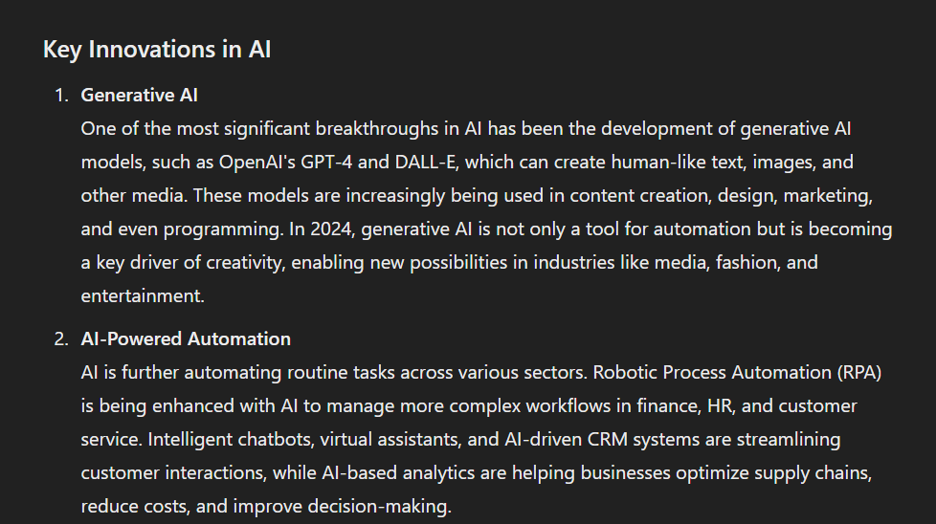

**Topic 2: Sci-Fi Short Story**

**Step 1**: **Basic Prompt**  
*"Write a sci-fi story about humans colonizing a new planet."*

**Output**:  
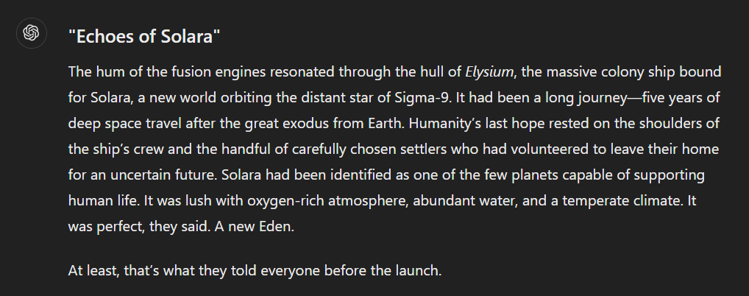

**Step 2**: **Refined Prompt with Tail Generation and Semantic Filtering:**  
*“Expand the story to include a conflict between human settlers and the planet's native species, with a focus on moral dilemmas and eventual resolution.”*

***Output:***

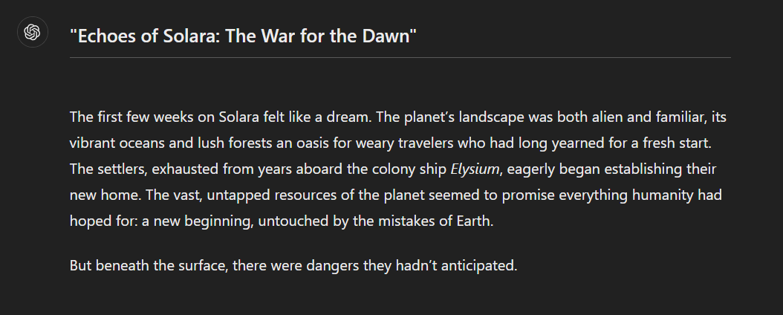

**Evaluation of the Generated Content:  
Scenario 1: Business Report on Market Trends  
Evaluation Criteria:**

1. **Clarity:**
   * The structure is clear with well-defined subheadings (Key Innovations, Market Impact, Future Outlook).
   * Each section provides concise, relevant information.
2. **Creativity:**
   * The report covers standard trends like AI and cloud computing. While insightful, it lacks groundbreaking examples or unique perspectives.
3. **Accuracy:**
   * The mention of AI contributing $15 trillion to the global economy by 2030 aligns with common projections but requires citation for credibility.
   * Ethical AI development is a recognized trend but could use specific examples (e.g., companies or technologies).

**Scenario 2: Sci-Fi Short Story  
Evaluation Criteria:**

1. **Clarity:**
   * The story progression is clear, moving from colonization to conflict and resolution.
   * The narrative is easy to follow, with vivid descriptions of the Luminae and their communication methods.
2. **Creativity:**
   * The inclusion of light-based communication for the Luminae is imaginative and unique.
   * The moral dilemma adds depth to the story, making it more engaging.
3. **Accuracy:**
   * While fictional, the story maintains logical consistency (e.g., bio-domes for unbreathable air, symbiotic energy sharing).
   * The resolution feels plausible and aligns with themes of interspecies collaboration.

**Deliverables:**

1. **First Drafts:**
   * Business Report: General overview of technology trends.
   * Sci-Fi Story: Initial colonization narrative.
2. **Refined Content:**
   * Business Report: AI-focused analysis with structured subheadings.
   * Sci-Fi Story: Expanded narrative with conflict and resolution.
3. **Multiple Versions:** Demonstrated the effect of advanced techniques on quality.
4. **Final Versions:** Polished and coherent outputs.

**Conclusion:**By applying various prompting techniques, you can generate high-quality content for a wide range of use cases, from business reports and case studies to creative works like short stories and articles. This experiment demonstrates how structured prompting can guide AI models like ChatGPT to create coherent, accurate, and engaging outputs tailored to specific needs.